3GPP TSG RAN WG1 Meeting #125 R1-2604859
China, Dalian, May 18th – May 22nd, 2026

Agenda Item: 10.8.2
Source: CEWiT
Title: Discussion on aspects of integration with communication
Document for: Discussion

Introduction
The new study item on 6G Radio was approved in RAN#108 [1], where the study on Sensing was agreed with the objectives cited as following:

(9) Sensing – Studies to be based on use cases and associated requirements, as defined in [TR38.914]
a) PHY functions and procedures for sensing technology (e.g., waveform. reference signals, measurement feedback, etc…) [RAN1, RAN4]
b) Evaluate sensing performance and if necessary, extend channel modelling, for the selected use cases [RAN1]
c) Aspects of integration with communication services [RAN1]
d) higher layer procedures and protocol aspects [RAN2]
e) RAN4 aspects of sensing including RF, coexistence, and testability in coordination with other WGs [RAN4]

In this contribution, we explore the use case of sensing-assisted communication, with a specific focus on sensing-assisted handover, where the required sensing measurements, the various sensing modes, and the overall handover procedure are discussed. Additionally, we address measurement-reporting metrics relevant to key 6G use cases, including health-related and structural monitoring.

Discussion
At the RAN# 124 bis meeting, the following proposal was considered for discussion regarding the sensing-assisted communication usage scenario.

[FL3][H] Proposal 4.9-1-rev4
- For the purpose of study, companies are encouraged to bring up usage scenarios for sensing assisted communication. For each usage scenario, please input at least the following aspects
  - Which feature of communication is to be assisted?
  - Which sensing measurements are useful for the assistance?
  - How the sensing measurements are used to assist the feature of communication?
  - Up to company to report the additional impact to physical layer designs, if necessary
- Note: whether/how to evaluate a usage scenario is to be discussed in 10.8.1

Integrating sensing and communication within the same network infrastructure enables mobile systems to perceive and anticipate the surrounding environment in addition to data transmission. Key applications include autonomous vehicles in industrial settings, UAV surveillance in urban areas, , and sensing-assisted high-throughput or collaborative vehicular services [2]. A major advantage of this integration is efficient resource utilization at both the network and UE. For example, when a UE transitions from line-of-sight (LoS) to NLoS conditions such as a bus moving behind a building, sensing information can enable proactive handover to a more suitable base station before link degradation occurs. This reduces call drops, lowers UE transmit power, and optimizes network resource usage.

2.1 Sensing-Assisted Handover

Efficient mobility management in cellular networks relies on faster handover (HO) to maintain seamless connectivity without interruption or noticeable performance degradation as a UE moves between cells. The mobility handling mechanism depends on the UE state (idle, inactive, or connected). In the connected state, mobility is typically network-controlled: the UE measures and reports the signal quality of neighboring candidate cells, and the network decides when to trigger a handover.
However, in dense 5G/6G deployments with small cells and high-mobility UEs, frequent handovers lead to increased signaling overhead due to continuous measurements and reporting. To address this limitation, sensing-assisted communication enabled by Integrated Sensing and Communication (ISAC) offers a promising alternative. Cells equipped with ISAC capabilities can actively sense and track the UE or vehicle by transmitting sensing signals and analyzing their echoes. This enables real-time estimation of key parameters such as distance, velocity (via Doppler), angular position (azimuth and elevation), and movement direction. Using this sensing information, the network can make more proactive and accurate handover decisions, reducing reliance on frequent UE measurements and thereby lowering reference signal and reporting overhead.

Proposal 1: Sensing-assisted handover can be considered a key use case of sensing-assisted communication for enhancing UE mobility management, with the objective of reducing signaling and measurement overhead.

Proposal 2: The following sensing measurements are essential to support sensing-assisted handover applications:
- Range (distance) information of the target
- Doppler (velocity) information of the target
- Angular information (azimuth and elevation) of the target

2.2 Sensing Modes and Handover Mechanism

To perform sensing-assisted handover, the following sensing modes and procedures have to be considered:

- TRP-based Mono-Static sensing
- TRP-TRP Bi-Static sensing

2.2.1 Handover Using TRP-based Mono-Static sensing

TRP-based mono-static sensing: In this sensing mode, the serving TRP and neighbouring TRP transmit the sensing reference signals and receive the reflected echoes from the sensing target, as shown in Fig.1. The received echo signals are used for sensing measurement.

Sensing RS
SSensing
Echo

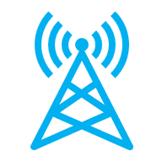



Fig 1. Sensing-assisted handover with TRP-based mono-static sensing

Handover Procedure

The serving and neighbouring TRPs first transmit sensing reference signals (RS). These signals propagate through the environment and reflect off the sensing targets, after which the serving and neighbouring TRPs receive the echoes. Based on the received signals, the TRPs process and extract relevant sensing information such as delay, Doppler, and angle parameters. This sensing information is then shared and exchanged among the serving and neighbouring TRPs to improve the overall understanding of the target and environment. Finally, using aggregated sensing information, the serving cell decides on handover. The service flow for the TRP monostatic sensing has been given in the Fig.2.

Serving &Neighbouring TRPs transmit sensing RS

Serving &Neighbouring TRPs receives echo from sensing target
Serving &Neighbouring TRPs exchange sensing information
Serving cell decides handover
Serving &Neighbouring TRPs obtain sensing information

Fig 2. Service flow for the sensing-assisted handover with TRP-based mono-static sensing

2.2.2 Handover Using TRP-TRP Bi-Static sensing

TRP-TRP bi-static sensing: In this sensing mode, the serving TRP transmit the sensing reference signals and the neighbouring TRP receives the reflected echoes from the sensing target, as shown in Fig.3. The received echo signals are used for sensing measurement.

Sensing RS
SSensing
Echo





Fig 3. Sensing-assisted handover with TRP-TRP bi-static sensing

Handover Procedure

In this sensing-assisted handover procedure, the serving TRP first transmits sensing reference signals (RS). The neighbouring TRP then receives the echoes reflected from the sensing target and processes these signals to obtain relevant sensing information, such as distance, velocity, and angular parameters. After extracting this information, the neighbouring TRP forwards the sensing results to the serving TRP. Based on the aggregated sensing information received from neighbouring TRPs, the serving cell makes a decision regarding whether and when to trigger a handover. The service flow for the TRP-TRP bistatic sensing has been given in the Fig.4

Serving TRP transmit sensing RS

Neighbouring TRP receives echo from sensing target
Neighbouring TRP sends sensing information to serving TRP
Serving cell decides handover
Neighbouring TRP obtain sensing information

Fig 4. Service flow for the sensing-assisted handover with TRP-TRP bi-static sensing

Proposal 3: For the sensing-assisted handover, the following sensing modes are to be prioritised:

- TRP mono-static sensing mode
- TRP-TRP bi-static sensing mode

- Measurement Report

At the RAN # 124 bis meeting, the following agreement was reached regarding the measurement report.
Agreement:
- On measurement for ISAC, study at least the following aspects.
  - Measurement definitions/levels for TRP-side measurement, taking the measurement Levels studied in NR ISAC as starting point
  - Measurement definitions/levels for UE-side measurement
  - Impacts of non-ideal factors on measurement
  - Other aspects are not precluded
  - Note: this discussion may or may not mean there is specification impact

For TRP-side measurements in 5G NR, a baseline agreement has already been established for sensing measurement reporting. This agreement, further discussed during the RAN #124 bis meeting, has also been adopted as a starting point for defining TRP-side measurements in 6G systems. On the UE side, the existing 5G NR positioning framework can be leveraged as a useful foundation. In particular, for downlink-based positioning methods, the UE performs measurements related to path characteristics such as time or delay of arrival and angle of arrival. These measurements are aligned with the so-called Level C measurements defined in the earlier agreement. Therefore, for UE-side sensing measurements, it is reasonable to consider the existing framework and associated agreement as a starting point.

Agreement
From RAN1 perspective, the following measurements that may be reported from RAN are identified in the study of NR ISAC. Note: Down selection of Level(s)/Option(s) for recommendation can be discussed separately.
- Level A: Raw data per Tx antenna port per OFDM symbol per RX antenna port per TRP for a given time stamp
  - Option A1: Amplitude and phase samples in time/delay domain of the estimated channel, i.e., Amplitude and phase values of channel impulse response
  - Option A2: Amplitude and phase per subcarrier in frequency domain of the estimated channel
- Level B: Amplitude and phase profile of delay, and/or Doppler, and/or angle per TRP for a given time stamp by using window(s) of the [consecutive] samples in delay, Doppler and/or angle domain
  - Option B1: Delay-Doppler profile per Tx antenna port per Rx antenna port, which includes the amplitude and phase samples distributed across different delays and Doppler shifts.
  - Option B2: Delay-Angle profile per Tx antenna port per OFDM symbol, which includes the amplitude and phase samples distributed across different delays and spatial angles (e.g., Angle of Arrival).
  - Option B3: Delay-Doppler-Angle profile per Tx antenna port, which includes the amplitude and phase samples distributed across delay, Doppler, and angle domains.
  - Option B4: Delay profile per Tx antenna port per OFDM symbol per Rx antenna port, which includes the amplitude and phase samples distributed across different delays.
  - Note: Level B is applicable for either LCS or GCS
- Level C: per detected path/point measurements per Tx antenna port per TRP which may be reflected/scattered from scattering point(s).
  - Option C1: Delay/range, Doppler/velocity, one or multiple 3D angles, and [power/confidence metric] per detected path for a given time stamp.
    - A path is associated with one couple {delay/range, Doppler/velocity, [power/confidence metric]}, and one or multiple 3D angles.
  - Option C2: Doppler/velocity, position, and [power/confidence metric] per detected path for a given time stamp.
    - A path is associated with one doppler/velocity, [power/confidence metric], one or multiple positions
  - Option C3: Delay/range, Doppler/velocity, 3D angle, and [power/confidence metric] per detected path for a given time stamp.
    - A path is associated with one delay, and one or multiple triple {Doppler/velocity, 3D angle, [power/confidence metric]}
  - Option C4: Delay/range, Doppler/velocity, 3D angle, and [power/confidence metric] per detected point for a given time stamp
    - A point is associated with one range/delay, one Doppler/velocity, one 3D angle
  - Option C5: Position, velocity, and [power/confidence metric] per detected point for a given time stamp
    - A point is associated with one position, one velocity
  - FFS: Velocity can be
    - Opt 1: radial velocity
    - Opt 2: 3D velocity
  - Note:
    - Position can be defined in either LCS or GCS
    - Angle can be defined in either LCS or GCS
    - Ambiguity issue will be further discussed
    - 3D angle refers to a pair of horizontal and vertical angles
- Level D: Object/target level measurement [per TRP or per gNB]
  - One or more value pair(s) {position, velocity} in GCS for a given time stamp is reported for a detected object/target,
    - Option D1: Only one value pair {position, velocity} in GCS for a given time stamp is reported for a detected object/target. The association of multiple measurements across different time stamps for the same detected object/target is not reported.
    - Option D2: Only one value pair {position, velocity} in GCS for a given time stamp is reported for a detected object/target. The association of multiple measurements across different time stamps for the same detected object/target is reported.
    - Option D3: One or more value pairs {position, velocity} in GCS for a given time stamp are reported for a detected object/target. The association of multiple measurements across different time stamps for the same detected object/target is reported.
    - Option D4: One or more value pairs {position, velocity} in GCS for a given time stamp are reported for a detected object/target. The association of multiple measurements across different time stamps for the same detected object/target is not reported.
  - Note: Ambiguity issue can be further discussed if any
  - Note: velocity is 3D velocity for Option D2/D3
  - FFS: velocity can be radial velocity or 3D velocity for Option D1/D4
- Note: the possible information from RAN to SF for further processing can be further discussed for all levels
- Note: the possible information from SF to RAN can be further discussed for all levels
- Note: confidence metric can be further discussed for options of Level C/D
- Note: definition of time stamp for each of all options of all Levels can be further discussed
- For Level A/B/C, Tx antenna port means reference signal antenna port for sensing purpose

Proposal 4: For UE-side sensing measurements, the existing TRP-based measurement framework defined in 5G NR can be considered as a starting point.

In 6G systems, the Radio Access Network (RAN) is expected to evolve into an intelligent entity, often referred to as an AI-native base station (aNB), where artificial intelligence and machine learning capabilities are deeply integrated into the network. Unlike conventional RAN architectures that primarily focus on communication, the aNB will enable joint communication and sensing (ISAC), allowing the network to perceive, interpret, and react to the surrounding environment.
With this AI capability, the RAN can perform advanced sensing functions such as object detection, recognition, and classification. For example, consider the scenario of distinguishing between two unmanned aerial vehicles (UAVs), namely UAV A and UAV B. Traditional sensing parameters such as delay, Doppler, and angle may not be sufficient to accurately differentiate between similar objects. In such cases, micro-Doppler information becomes highly valuable. Micro-Doppler captures fine-grained motion characteristics caused by rotating parts (e.g., propellers of drones) or subtle movements, which can serve as a unique signature for object classification. This is particularly important for applications like drone identification, surveillance, and security.
Furthermore, micro-Doppler information is also highly relevant for health-related sensing applications, such as monitoring human activities [3], respiration (breath rate) (as shown in Fig.5), and other vital signs. These applications rely on detecting very small periodic motions, which are effectively characterized by micro-Doppler signatures. Therefore, incorporating micro-Doppler as an input to the sensing algorithms significantly enhances the capability of the RAN to support such use cases.

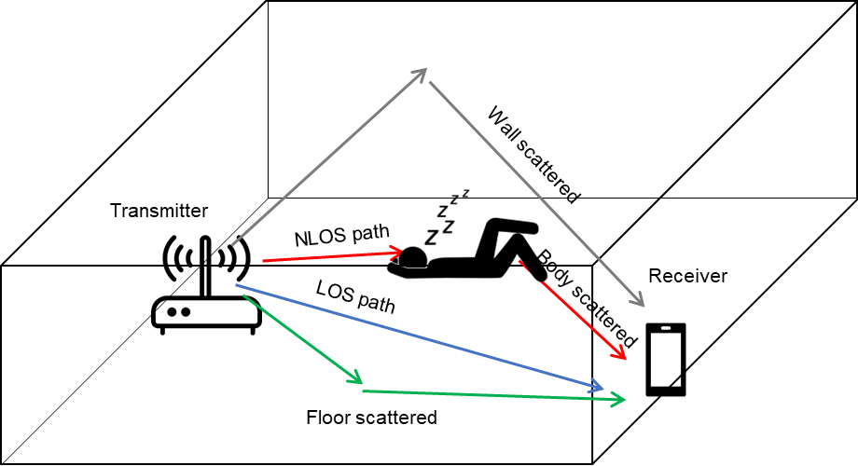
Fig. 5 People’s respiration rate monitoring using the micro doppler signatures

Similarly, for structural monitoring applications (as shown in Fig.6), such as bridges and buildings, another important parameter is deformation information. Structural deformation reflects changes in shape or displacement over time and is critical for assessing the integrity and safety of infrastructure. Conventional sensing parameters may not adequately capture these slow and subtle changes, whereas deformation metrics provide direct insight into structural health.
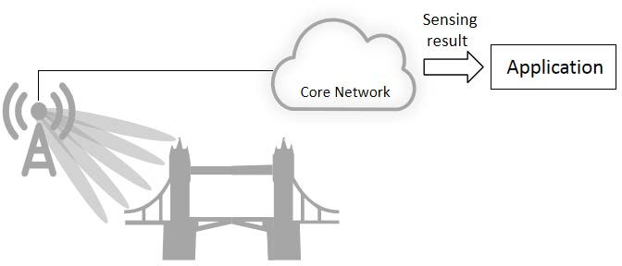
Fig. 6 Micro-deformation sensing

Given the importance of these advanced sensing features, it is essential to enhance the existing measurement reporting framework. In addition to conventional parameters like delay, Doppler, and angle, the measurement report should explicitly include:
Micro-Doppler information for fine-grained motion analysis and classification
Deformation information for structural monitoring and infrastructure assessment
Including these parameters in the measurement report will enable the AI-enabled RAN (aNB) to support a wide range of advanced applications, from UAV classification and human activity recognition to smart infrastructure monitoring. This enhancement aligns with the vision of 6G as a fully integrated sensing and communication system, where the network not only connects devices but also understands and interacts intelligently with the physical world.

Observation 1: In 6G, integrating artificial intelligence into the RAN enables advanced sensing capabilities, allowing the network to classify objects and estimate health-related parameters using micro-Doppler signatures as inputs.

Observation 2: Sensing can support structural monitoring by capturing deformation-related information.

Proposal 5: Support micro-Doppler signatures and structure deformation as measurement parameters for sensing applications

3. Conclusion
This contribution provides the following observations and proposals on aspects of integration with communication.

Observation 1: In 6G, integrating artificial intelligence into the RAN enables advanced sensing capabilities, allowing the network to classify objects and estimate health-related parameters using micro-Doppler signatures as inputs.

Observation 2: Sensing can support structural monitoring by capturing deformation-related information.

Proposal 1: Sensing-assisted handover can be considered a key use case of sensing-assisted communication for enhancing UE mobility management, with the objective of reducing signalling and measurement overhead.

Proposal 2: The following sensing measurements are essential to support sensing-assisted handover applications:
- Range (distance) information of the target
- Doppler (velocity) information of the target
- Angular information (azimuth and elevation) of the target

Proposal 3: For the sensing-assisted handover, the following sensing modes are to be prioritised:

- TRP mono-static sensing mode
- TRP-TRP bi-static sensing mode

Proposal 4: For UE-side sensing measurements, the existing TRP-based measurement framework defined in 5G NR can be considered as a starting point.

Proposal 5: Support micro-Doppler signatures and structure deformation as measurement parameters for sensing applications

4. References
- RP-251881, New SID: Study on 6G Radio, NTT DOCOMO (Moderator).
- ETSI GR ISC 001, “ISAC Use cases and deployment scenarios”, V1.1.1, 2025.
- TR 22.837, “Feasibility study on integrated sensing and communication” V1.0.0, Release 19

